**Project Title:**

**IOT BASED CROP PROTECTION SYSTEM FOR AGRICULTURE**

**Project Design Phase-I** - **Solution Fit Template Team ID:**

**PNT2022TMID31899**

* Farmers who trying to protect crops from various problems
* Limited supervision.
* Limited financial constrains.
* Lack of man power.
  + Automation in irrigation.
  + CCTV camera to monitor and supervise the crops.
  + Alarm system to give alert while animals attacks the crops.
  + Crops are not irrigated properly.
  + Improper maintenance of crops.
  + Lack of knowledge among farmers in usage of fertilizers and hence crops are affected.
  + Requires protecting crops from Wild animals attacks, birds and pests.
* Due to insufficient labour forces.
* Due to various environmental factors such as temperature climate, topography and soil quality which results in crop destruction.
* Due to high ammonia, urea, potassium and high PH level fertilizers.
* Crops are damaged and it affects growth.
  + Asks suggestions from surrounding peoples and implement the recent technologies.
  + Consumes more time in crop land.
  + Searching for an alternative solution for an existing solution.
    - By seeing surrounding crop land with installing machineries.

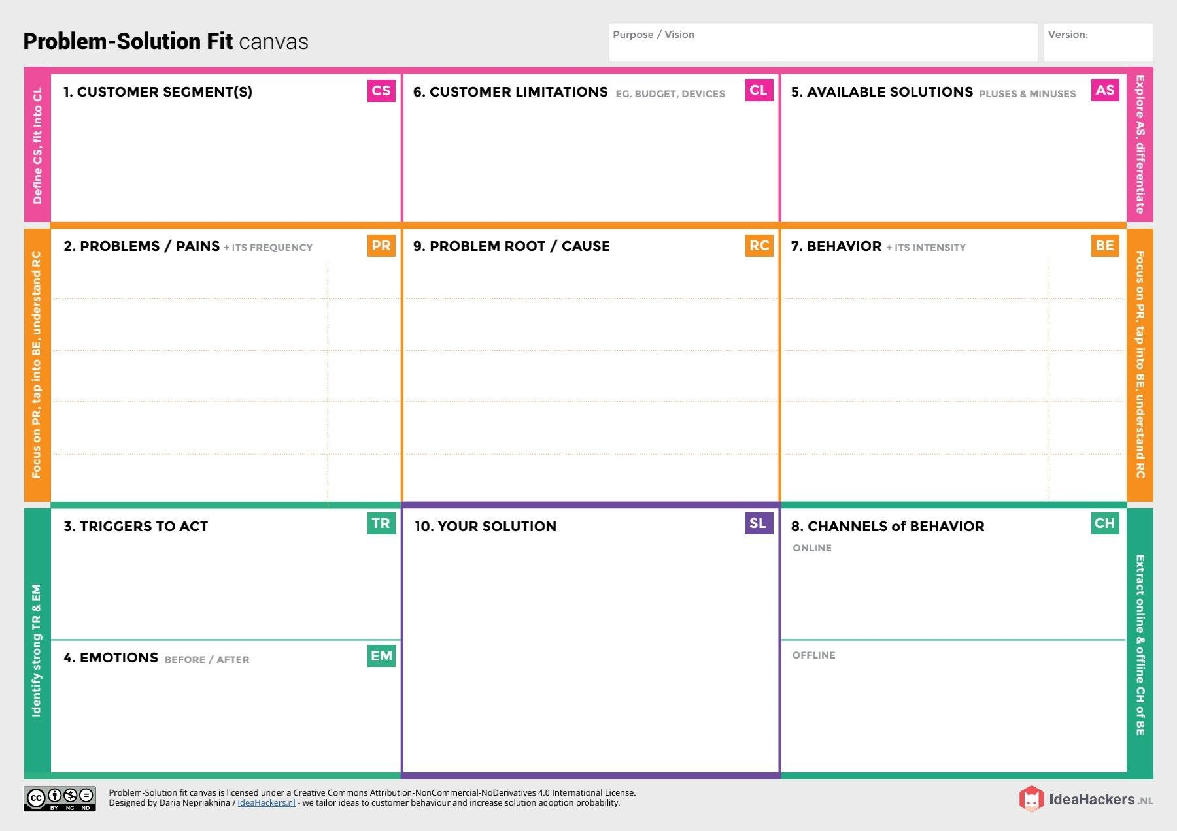

* + - Hearing about innovative technologies and effective solutions.
    - Mental frustrations due to insufficient production of crops.
    - Felt smart enough to follow the available technologies with minimum cost.
* Moisture sensor is interfaced with Arduino Microcontroller to measure the moisture level in soil and relay is used to turn ON and OFF the motor pump for managing the excess water level. It will be updated to authorities through IOT.
* Temperature sensor connected to microcontroller is used to monitor the temperature in the field. The optimum temperature required for crop cultivation is maintained using sprinklers.
* IOT based fertilizing methods are followed, to minimize the negative effects on growth of crops while using fertilizers.
* Image processing techniques with IOT is followed for crop protection against animal attacks.
  + Using different platforms /social media to describe the working and uses of smart crop protection device.
  + Giving awareness among farmers about the application of the device.